**COVID-19 Command Center in Belagavi**

Integrated Command and Control Center at Belagavi will be made available to support Covid-19 situation by enabling communication to outside world through calls and Mobile App. Video conferencing will be enabled to hold emergency meetings with concerned stakeholders for rapid response. Relevant identified information will be displayed on CCC platform (map-view) for better emergency response to handle covid-19 situation.

**Problem to address:**

* Currently the only effective way to contain COVID-19 is Social Distancing
* India is currently in stage 2, meaning the virus has mostly infected people with foreign travel history, their relatives and acquaintances in close contact.
* To contain the infection, most effective method will be to ensure that stage 2 Quarantined cases maintain strict social distancing.
* Stricter enforcement of Lockdown.

**Proposed Solution:**

* BEL provides a tool to ensure that stage 2 Quarantined cases are following the social distancing practice diligently.
* Using easy cell tower based mobile number tracking and app tracking solutions, we can track the movement of stage 2 Quarantined cases and raise an alert/notification in case there is any movement observed. The movement trail and approximate location, along with address can be seen on a live dashboard.
* Once the alert is raised, an automated call/SMS can be sent to the Quarantined cases to stay back home. Beyond a certain duration and radius of movement, authorities can intervene.



**Solution Architecture:**

The cloud architecture of the Analytics Platform simplifies the inclusion of additional solutions to address a wider range of urban service domains. The platform supports services across domains by allowing data to trigger predictions or actions in other domains based on the criteria established by and for your community. This functionality draws from the ability to combine data from many data sources, regardless of their individual integration technology, and communicate it securely while also tapping in to geospatial mapping for many important uses across your community. So, for example, by combining features from both parking and lighting domains, you can achieve features like parking space–specific lighting.

**Events and SOPs:**

The key to automation is events (alerts and notifications) – identifying and capturing events from different sources and processing those events to recognize that an action should be taken. The Automation engine can receive event notifications from all the systems and devices that have been integrated to the platform, and it can also process data streams in real-time to recognize patterns and events of interest in the data. The Complex Event Processing (CEP) engine can analyse and correlate these events and data streams and identify specific situations so that the operator can be notified and/or pre-configured operating procedures can be automatically activated.

A Standard Operating Procedure (SOP) Workflow is a set of operational tasks which should be carried out in a defined sequence. These may be automated tasks which can be executed without any further manual intervention (e.g. send an email with system-generated text to a predefined address), or they may be manual tasks where human intervention or resolution is required to complete the task. Platform provides a flow-based editor to define SOP workflows. A workflow usually can include different types of tasks, including the following:

* Email – send a context-sensitive system-generated email using a pre-configured template to one or more email addresses.
* SMS/Text Message – send a system-generated SMS message.
* Voice call – automatically initiate a telephone call
* Collaboration Rooms initiation via integration
* M2M task – invoke an external system
* Operator task
* Field Officer task – send a notification to a remote field officer

**Reports and AI Analytics:**

The Platform features a modular and scalable architecture built on big data infrastructure and is capable to ingest data from varied sources. It’s a design driven solution for cross vertical analytics which helps to quickly mash up data from varied sources and create visualizations on top of it. The whole solution provides a seamless experience during its operations whilst beautifully abstracting their intricacies in the lower layers.

Its cross-domain analytics engine leverages advanced machine learning capabilities of the platform to enable automate policies resulting in better management of assets and infrastructure. Key features include:

Real-time reports and Streaming Analytics from diverse sensor data APIs, other data sources connected to the platform

**Cross Domain Reports:** Enabling contextual information and correlation across domains and verticals

**Customized Reports:** A drag and drop interface to build customized reports

**Predictive Analytics:** Machine Learning based predictive models that integrate with multiple domains providing predictions that can help in policy/rule engine recommendations. Predictive analytics that help in disaster management scenarios with what-if analysis and event correlations

**Social Media Analytics:** Analytics that are based on social media trends along with NLP and sentiment analysis

**Predictive Analytics:** These models use data from sensors, IT and open data sources to forecast and predict future state. Some key applications are Parking Occupancy Forecasting, Environment prediction, Smart bin fill level predictions, Traffic Congestion Prediction.

**Prescriptive Analytics:** These models recommend action to be taken for optimizing city operations.

**Text Analytics:** Models for text analysis and natural language processing can be used for Classification, Sentiment Analysis and Conversational Interfaces

**Following use cases are implemented to support the COVID situation:**

1. COVID-19 Awareness messages (Audio) are being broadcasted through Public Addressing systems installed on intelligent poles.
2. COVID-19 Awareness messages (Text and Video) are being broadcasted through Digital Display Board installed on intelligent poles and bus shelters.

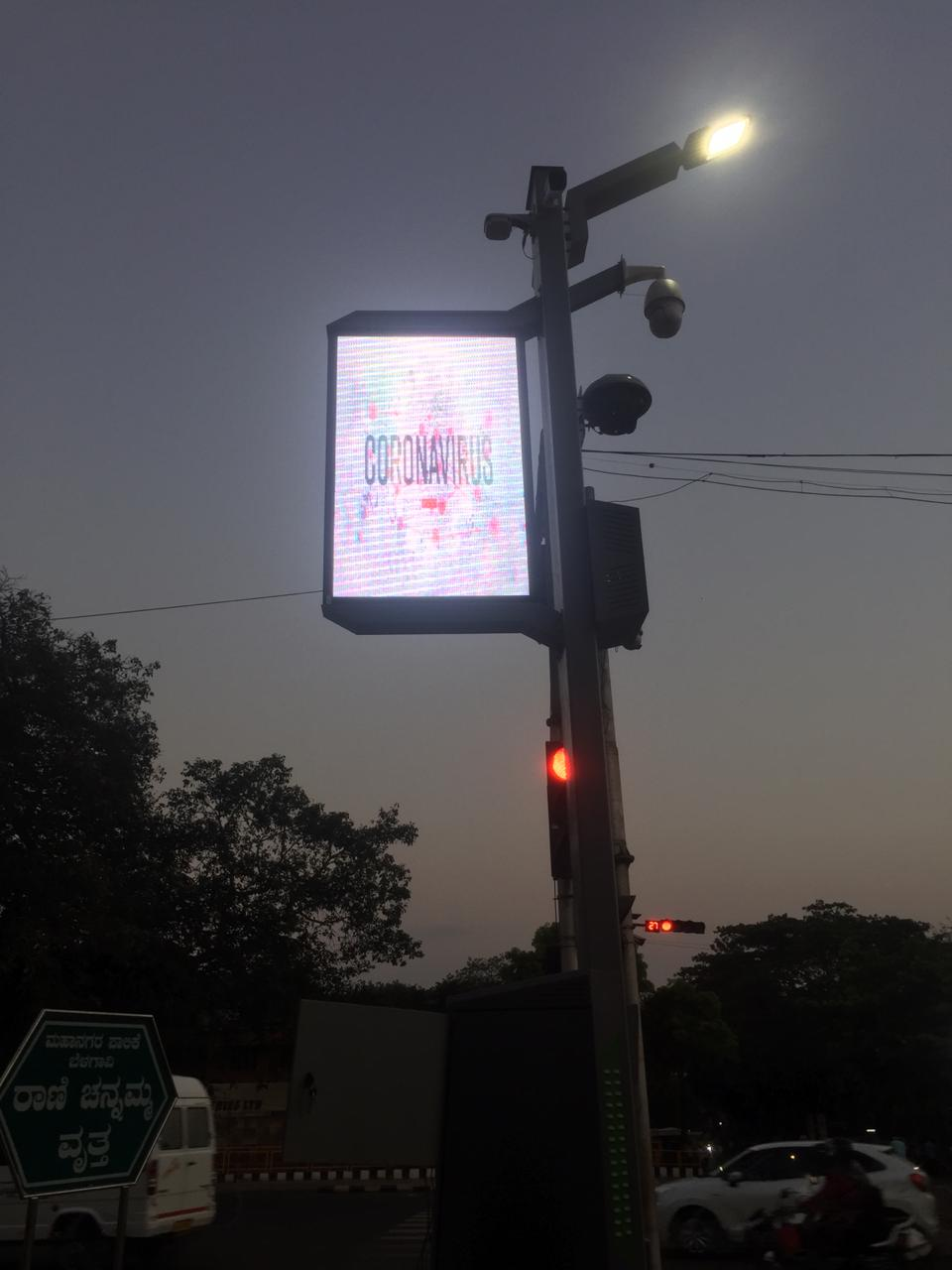

1. Stricter enforcement of lockdown through Surveillance cameras.
2. Video push feature is now available to health officials for immediately pushing video captured on their mobile phones to Command center for necessary action on the miscreants. This way miscreants can be tracked readily and lockdown situation can be better engaged. This will also help in remote monitoring where Surveillance cameras cannot see.

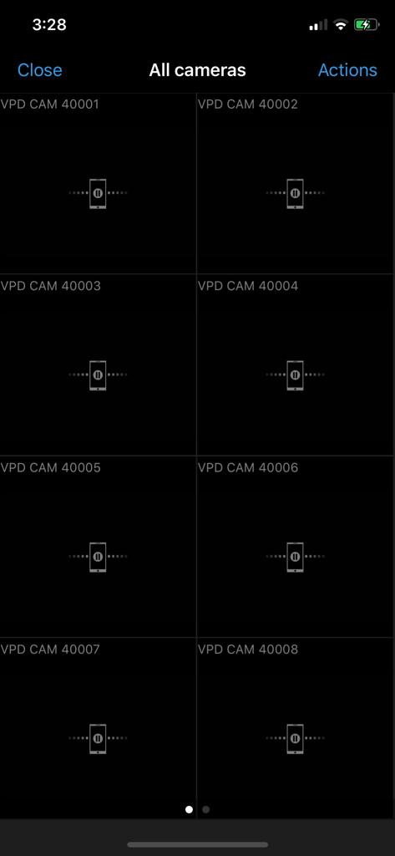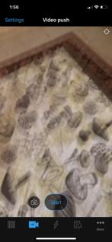

1. **Customized dashboards:** Home quarantined patients will be monitored and tracked on the below dashboard. Live stats of breaching, Tracking trail with address will be available on the Dashboard. Corresponding Notifications and alerts will be sent to the platform via Automated SMS/calls.

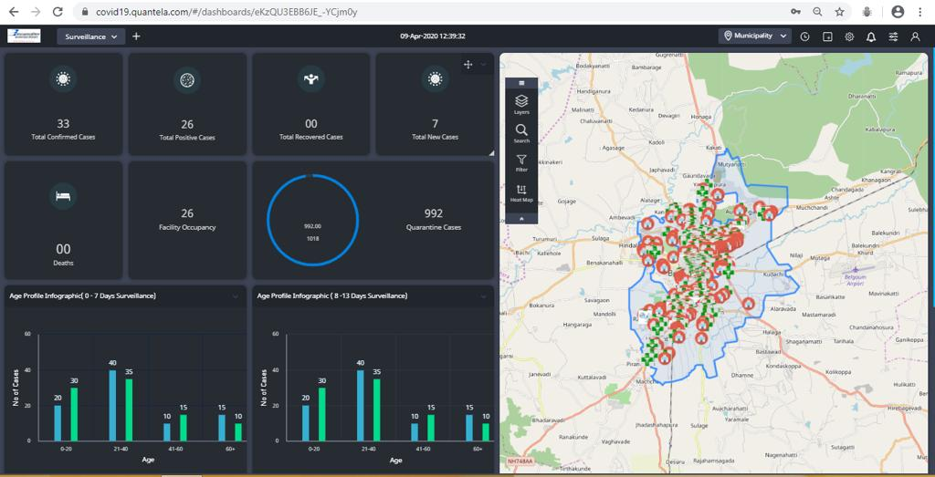

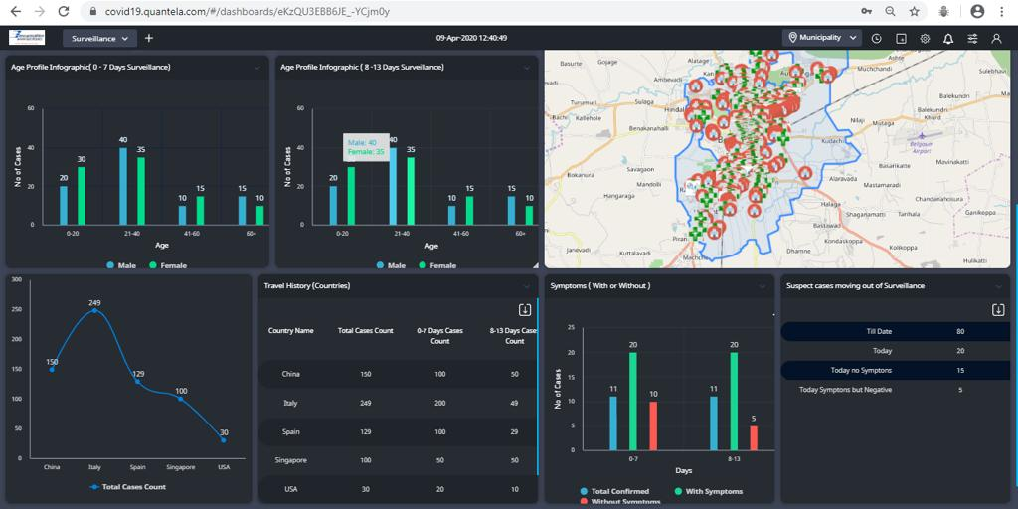

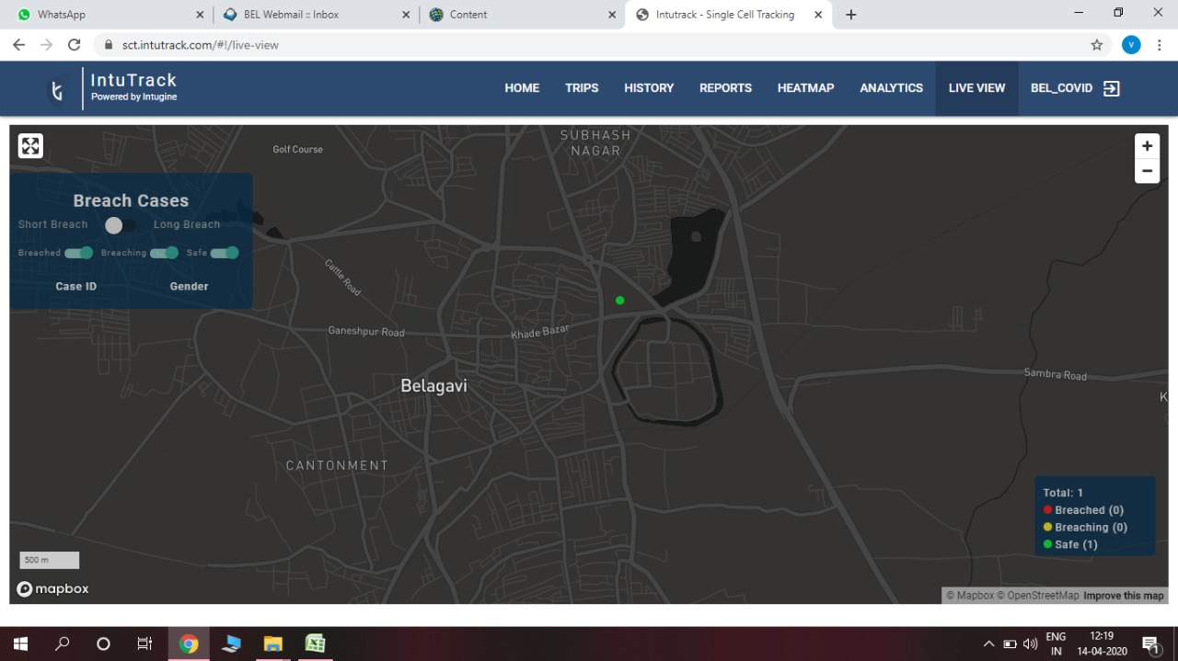

1. Citizen Apps are now available for download on Playstore. Citizens can use this app to get information on zones implemented across the city. Also, to scan the location for essential commodities store in the vicinity. Protection and prevention guidelines will be available to view and download. Self-assessment tests are available on the app for citizens to check their condition.

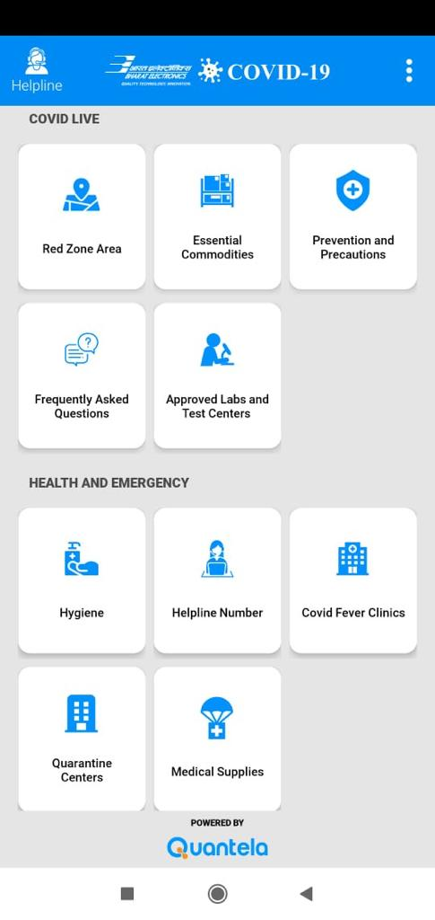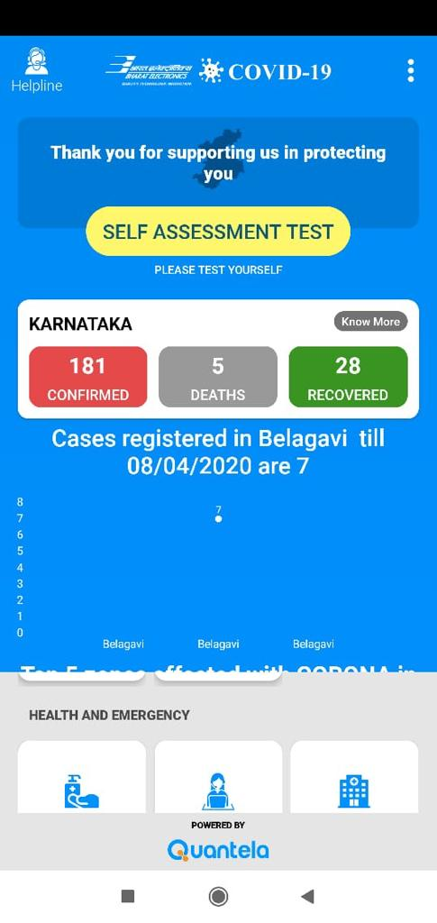

1. Health and emergency section will provide access to nearest COVID test and quarantine centers. Helpline will be available on phone and chat via apps. Automated chatbots are in the development and will soon be available to citizens through this app.

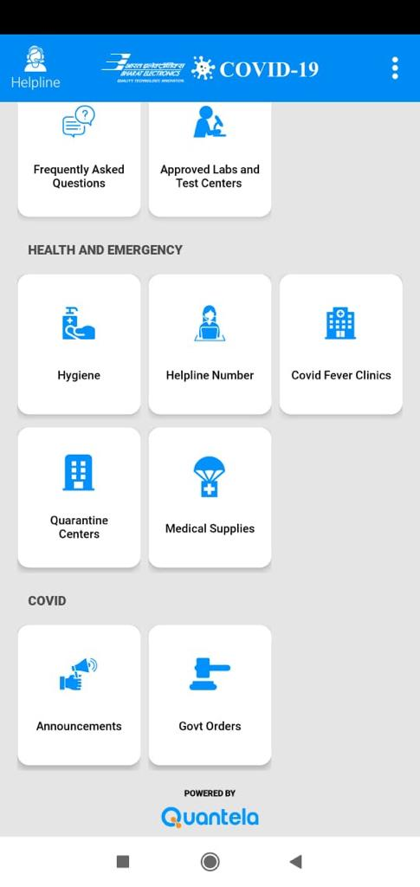

1. Field officer apps are provided to the identified resources of BSCL for contact tracing and patient reporting. Call operator feature is available for immediate assistance from command center. This app can be utilized for home assessment of the quarantined personnel.

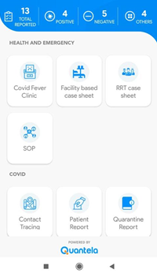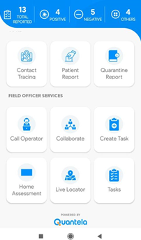

1. Video Conferencing call will be arranged from CCC and Mobile App directly with Health officials/doctors based on requirement gathered. 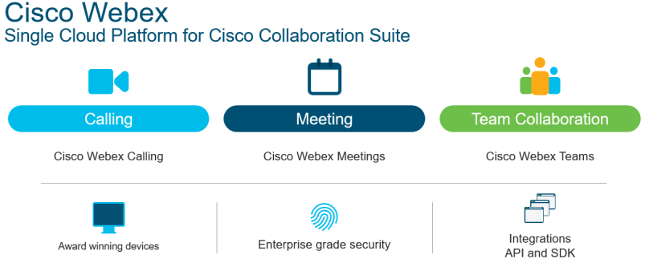

Rich Modular Services Designed for How You Work

1. Video analytics (loitering and crowd gathering) can also be implemented for better enforcement of lockdown by not having any human intervention, provided BSCL provides additional bandwidth and makes provision for this implementation. ***(Strictly for COVID-19 implementation)***





**Outcome:**

**Government Authorities:**

* Quarantined Individuals Location Heatmap
* Quarantined cases density data for allocating monitoring resources
* Automated reporting of daily stats

**Police Officers:**

* Real-time movement of people put under quarantine.
* On-the-go visibility on the number of people put under quarantine.
* Alerts raised if the quarantined people breach location radius thresholds

**Medical Authorities:**

* Predictive analytics to estimate the number of cases for improved planning
* By controlling the rapid spread of Infection, the solution can ensure that the number of cases do not exceed beyond the bandwidth of current Medical Infrastructure

**Citizens:**

* Live heatmap view of the nearby affected area.
* An additional interface can be added to for citizens to file Affidavit for travel pass for essential travel activities.
* An additional interface for requesting delivery of essential goods.